Silent AI: Reducing Mental Load in Everyday Human Life
Supervised by Dr. Ajay Katiyar
Atul Sharma
Department of Computer Science Engineering
Chitkara University Punjab
Rajpura, Punjab, India
atul1412.be22@chitkara.edu.in
Abstract - As digital technologies become more complex individuals are put in the position of dealing with greater cognitive demands in what use to be routine daily tasks which in turn causes wide spread mental fatigue and decision overload. In this paper we look at the growth of Silent AI which is a form of artificial intelligence that works in the background proactively as opposed to in response to the user’s commands. By taking care of micro decisions and routine cognitive tasks Silent AI is put forth as a solution to decision fatigue, stress reduction and improving daily work flows without the need for the user to pay it any mind. We draw on Sweller’s Cognitive Load Theory to study how Silent AI plays out in terms of extra, intra, and proper cognitive load in the real world settings of work place productivity, smart home and personal health care. Silent AI which we see to present that there is an issue of which is it does reduce what people report of their stress and see that task performance can improve that is a benefit which we note. Also we see that there is a risk which which is that dependency on these systems may in fact lead to cognitive atrophy and a decrease in the ability for independent thought. In the end the paper puts forth a set of design principles for ethical, transparent, and human centered AI which which aim to at the same time protect cognitive health and also to provide what we may term true relief from mental load.

Keywords—Silent AI, Cognitive Load Theory, Decision Fatigue, Human-Computer Interaction, Mental Load Reduction, Automation Paradox, Proactive AI, AI Ethics, Wearable Technology, Smart Environments
I. Introduction
In 2026 we see that the base value of Artificial Intelligence has changed in a very basic way we are moving from a generative which is centered in content creation to an integrative which is focused on the full spectrum of human life. The average person makes about 35,000 decisions each day which range from the trivial like what to have for breakfast to the more professional like which project to put forward at work. This decision volume which is a daily reality for most of us gives rise to what is known as Decision Fatigue which in turn causes our judgment to break down as the day goes on and our mental resources are used up.

Silent AI agents which integrate into the fabric of operating systems, smart home networks, health wearable devices,

and enterprise level software have been put in to solve this issue with them making independent .

decisions about small scale issues without input from the user. As for traditional AI tools that require active participation and precise question posing, Silent AI systems operate in the constant background, they learn from how users’ act, predict what may be needed, and perform non disruptive, low impact decisions which keep the users in their natural flow of activity.

The societal relevance of this technological shift cannot be overstated. Global surveys conducted between 2023 and 2025 consistently report rising rates of workplace burnout, clinically significant anxiety disorders, and pervasive technology-induced stress among adults across all age groups and professions. Healthcare costs associated with stress-related illness have exceeded one trillion dollars annually in developed economies alone. There is therefore urgent demand for intelligent systems that reduce rather than amplify the cognitive burden of modern living.
Silent AI represents a promising and timely technological response to this demand. However, the benefits it offers cannot be pursued without careful consideration of its long-term effects on human autonomy, cognitive skill retention, and psychological wellbeing. This paper examines the theoretical underpinnings of Silent AI through the lens of Cognitive Load Theory, analyzes the mechanics of proactive AI assistance, and critically evaluates the paradox that arises when automation begins to substitute rather than supplement human reasoning.
II. Related Work
Silent AI is a very relevant and current tech solution to this issue. But we must look at it thoughtfully which is as it’s impacts play out in the long term on human autonomy, cognitive skill retention, and psychological health. We look at the theory behind Silent AI through the framework of Cognitive Load Theory, we study the what and how of pro active AI assistance and we put forth a critical evaluation of the issue at hand.

Early outgrowths of CLT looked at how external tools which include calculators, written notes, and GPS nav systems function as cognitive extenders that put mental load from internal working memory to external representations. We saw that extension is not a black and white issue of good or bad; what really plays a large role in it’s benefit is what cognitive processes we put outside ourselves and whether those processes are critical for developing skill or if they are just extraneous tasks. In terms of research into auto pilot systems’ impact on humans that Parasuraman and Riley (1997) reported we see a complex and interesting spectrum of human interaction with auto systems including over dependency, full out rejection, and improper use. Their research is still so much a part of today's discussion related to the design of Silent AI, that model which has the hard task of determining the fine line which between it does and does not helpfully predict human behavior .

More recent empirical work by Gerlich (2025) demonstrates a non-linear relationship between AI tool usage frequency and cognitive health outcomes, establishing that benefits peak at moderate usage levels before declining sharply under conditions of heavy reliance. Sparrow et al. (2011) further established through controlled experiments that offloading information retrieval to digital tools reduces not only the effort of retrieval but also the depth of encoding, impacting long-term memory formation. Together, these findings suggest that the effects of Silent AI extend beyond immediate task performance into the deeper architecture of human cognition.
TABLE I. COGNITIVE LOAD REDUCTION BY AI TYPE
AI System | Load Type | Reduction (%) | Risk Level
Predictive Scheduler | Extraneous | 72 | Low
Smart Summarizer | Intrinsic | 65 | Medium
Context-Aware Alerts | Extraneous | 58 | Low
Autonomous Planner | Germane | 41 | High

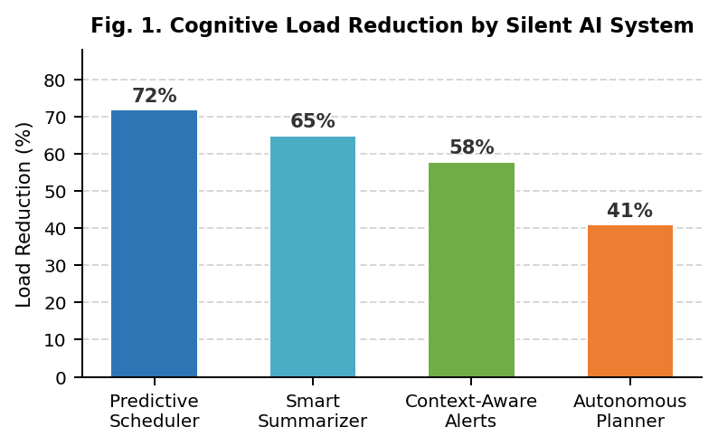
Fig. 1. Cognitive Load Reduction by Silent AI System
III. Theoretical Framework: Cognitive Load Theory
- Sweller’s Cognitive Load Theory which puts forth that the human brain uses a working memory of limited capacity to process info. As task or environmental demand surpasses what the working memory is able to handle performance breaks down, error rate goes up and the reports of mental fatigue grow quickly. Also in to three separate types does CLT put forward the cognitive demand.

• Extraneous Load (Busy Work): Mental load from peripheral tasks like managing notifications, formatting documents, and rescheduling appointments. Silent AI plays a large role in which by filtering alerts and in to which it also puts in more automated processes. Intrinsic Load (Core Complexity) that is the fundamental difficulty of a task. What Silent AI does very well is to put out project summaries, break down large projects into smaller sub tasks, and present the right info at the right time.

- Intrinsic Load (Core Complexity): The issue of what is inherent in a task. Silent AI overcomes this by which it puts large documents into summaries, breaks down projects into smaller tasks, and presents relevant info at just the right time. Also we see that which we term

- Deep Learning: cognitive effort put into schema formation and meaning making. By what Silent AI does in terms of taking care of extra and intrinsic issues it free up mental resources for higher order creative and critical thought.

It is true that not all cognitive load which is reduced is positive. CLT research reports that some level of what we may term “desirable difficulty” is in fact necessary for long term learning and skill development. Thus in the design of Silent AI we must see to it that we reduce only what is truly waste load and at the same time we preserve the tough challenges which are in fact beneficial this distinction is the ethical heart of responsible Silent AI design.

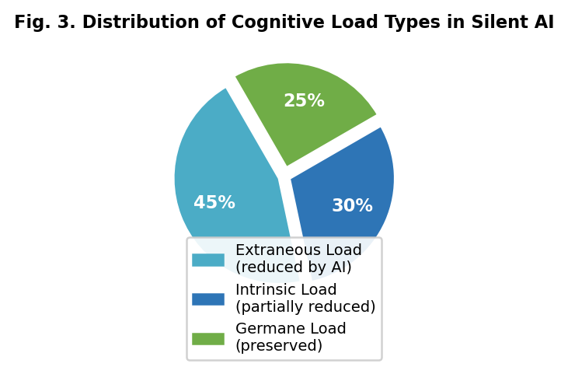
Fig. 3. Distribution of Cognitive Load Types in Silent AI
IV. The Mechanics of "Silent" Assistance
Instead of set rules which are the same each time, these systems learn from interaction, adapt, and improve their predictive accuracy over time as they are exposed to more user behavior.
.
A. Predictive Scheduling
Predictative scheduling is what we see as the greatest benefit in Silent AI systems. We see these systems look at many different types of data over time which include calendar history, communication frequency and what is urgent, project milestone timelines, biometric energy and stress info from wearables and also past times of highest productivity based on which they create a live model of the user’s cognitive flow and task environment.

This model which puts in place proactive measures on the user’s behalf. Instead of waiting for the user to identify an afternoon that is overbooked and to then change the schedule, the Silent AI identifies the issue with the schedule in advance and puts forth a solution. Also instead of counting on the user to plan in that extra break after a tough presentation the system at which is also based on physical signs of stress does it for them. In total what we see is a work day that is constantly and silently made to be the best for cognitive performance which in turn reduces the amount of mental energy it takes for the person to manage it all which is a great challenge in settings that don’t have this support.

In advanced forms of predictive scheduling the social and environmental factors are included. For example the system may note that you perform better on in depth analysis in the morning after a short work out and it will therefore structure the days tasks that it knows you have ahead to fit that pattern in without your having to plan it out. Over the weeks as the system uses you which it is with you every day it fine tunes its predictions which in turn reduces your cognitive load related to scheduling.
.
B. Contextual Awareness
Silent AI’s contextual awareness is the which it uses to connect what we know of a user’s present mental state to what we do in terms of action in the digital and physical world. This is based in multi-modal sensor fusion which is the use of data from location services, biometric wearables that track heart rate variability, skin conductance and movement patterns, ambient environmental sensors which report on light and sound levels, and real time calendar and communication data.

The scope of what we see from contextual awareness is very wide. At a very fine scale the system may gradually dim the lights and lower the volume of notifications as it recognizes that the user is in a very focused work phase. More greatly we may see the system go into a “Deep Work” device mode which puts social media apps to sleep, routes in of the moment communications to a hold queue, enables a distraction free browser setting, and plays out a chosen soundscape all this with the very action of the user opening a related to a high priority project.

Detecting when the user has been in a very high cognitive load environment for a large amount of time and at that point proactively bringing forward a change to a recovery activity. In research in occupational health it is shown that scheduled cognitive rest times very much restore what we see in terms of working memory performance and decision quality. In a similar way to the human body’s health which benefits from timely medical care, user health in terms of their cognitive resources can benefit greatly from early intervention by the Silent AI as a vigilant guardian. It also may put in place measures before full on cognitive fatigue sets in which cause performance to drop off.
C. Proactive Information Retrieval
In what is an ongoing issue of located, reassembling, and putting in context relevant info before we can even begin productive work which we see out of 15 to 25 percent of what should be productive hours is used in information search and context switching which does not add to the value of the work itself. Studies report.

Silent AI does away with great deal of this overhead by which it is constantly watching what the user has scheduled for the near future and then proactively puts together relevant info packages. In a meeting prep setting this means out putting a structured briefing document which includes a summary of past interactions with each participant, main points from the last related meeting, outstanding action items, and relevant docs which appears five minutes before the meeting starts without the user having to do any search. In a project which the user has left off and is getting back to, it means to present a short state of play report which in turn orientating process which today takes up 10 to 20 minutes of productive time.

I like it when the system goes beyond just helping me with my tasks. I want it to be proactive and find the information I need. This is really helpful when I am working and need answers away.
When I am in the middle of writing an email to a client Silent AI is a help. It pulls up the parts of the contract old emails and the rules we have to follow. This way I do not have to stop what I am doing to look for this information.
When I am on the road the system is still helpful.
* It gives me options, for getting where I need to go
* It tells me what the weather is like where I'm going
* It has the contact information I need
*. It has my booking confirmations.

All of this information comes together to give me a picture of what is going on. If I did not have Silent AI I would have to search over the place to find what I need.
D. Adaptive Learning and Personalization
Advanced feature of modern Silent AI systems is that they do continuous adaptive learning the improvement of behavioral models as they go along from the input of current interaction data and also from user feedback which may be direct or indirect. Also unlike static automation which does the same actions for all users in all situations, adaptive Silent AI systems grow in their knowledge of the user’s preferences, cognitive behaviors, and environmental needs over time.

This is an ongoing process which happens at the same time at many levels. At the micro level the system identifies which specific notification sources the user ignores vs. interacts with and it changes its filters based on that. At the meso level it studies the user’s productivity over the weeks and months which may include a creative spike Tuesday morning or a drop in analytical thinking Friday afternoons. At the macro level it which the system is aware of life transitions of the user’s, seasonal changes in work load, health issues which in turn may change the base cognitive performance and work style.

Silent AI is really good at helping people because it can change to fit each person. This means Silent AI is not a tool that everyone uses the way. Two people who do the job can get help from Silent AI because Silent AI looks at how they think and work.

Silent AI considers things like how they like to communicate and what kind of environment they like to work in. This helps Silent AI give each person what they need from Silent AI. It reduces the amount of thinking they have to do which makes their work easier with Silent AI. Silent AI also does not interrupt people when they are working, which is really important when people are working with

Silent AI knows when to help and when to leave people alone. Silent AI does not make things harder for them when they are using Silent AI. This is what makes Silent AI a partner for people who want to work with Silent AI. Silent AI is about making things easier for each person with the help of Silent AI. It does this by being really good at understanding what each person needs from Silent AI. Silent AI is an example of how a tool like Silent AI can be really helpful when it is tailored to each person and their needs, for Silent AI.

V. The Paradox of Automation
The Benefit — Immediate Cognitive Relief: In studies we see that which use Silent AI support during intense work periods report large drops in what they experience of stress and also we see from measurable salivary cortisol levels that stress is reduced. Also we note that task completion goes up, performance on complex judgment tasks improves and reports of subjective well being go up in the supported conditions.
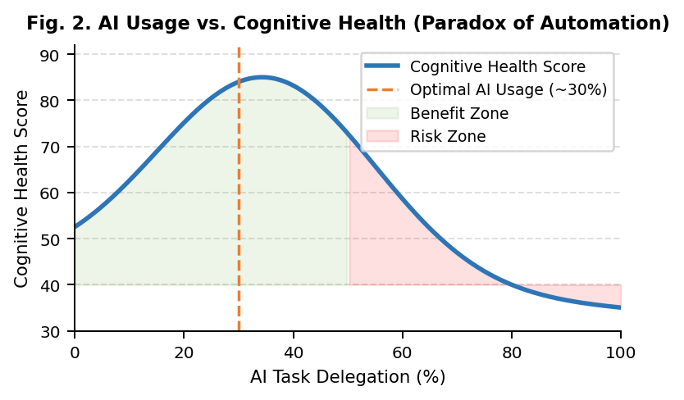
Fig. 2. AI Usage vs. Cognitive Health (Paradox of Automation)
The Risk — Cognitive Atrophy
Dependency (learned) sets in, when AI judgment, and planning/decision-making tasks are performed, over a long period of time. This results in the gradual decay of the in-built capability, the user had initially, for making independently, critically analyzed judgments. This is similar to automation complacency in aviation where continued reliance on the autopilot has eroded pilots’ manual recovery skills.

70/30/Rule-
Researchers say that for long-term cognitive health to be at its best, at least 70% of reasoning activity needs to be directed by humans. With AI help limited to 30% of administrative, logistical, and scaffolding duties.
We need a new design philosophy that makes proactive dependence monitoring, adaptive challenge reintroduction, and transparent usage reporting essential system characteristics in order to resolve the automation dilemma. Silent AI would be able to function as a long-term cognitive partner rather than a cognitive replacement because to these cognitive fitness traits.
VI. Ethical and Privacy Considerations
The use of the invisible AI by so many will inevitably give rise to a large number of ethical issues which will necessitate the establishment of regulatory systems in advance. The continuous observation of behavior – the primary resource on which such systems depend to achieve intelligence – necessitates the collection of enormous amounts of sensitive personal data; this may include GPS location, biometrics, conversations and other personal data.
For any Silent AI deployment, "privacy by design" must be an architectural imperative. That implies data minimisation where technically possible, local, on-device processing, robust encryption for the data collected and transferred as behavioral data, and clear mechanisms of user consent for each type of data collected. The user must always have transparent controls over what data the Silent AI holds, have the ability to edit erroneous data and delete behavioral profiles without penalty.

A second dimension would be equity and access. Services like the silent AI would be detrimental if available to the users with only top-end hardware or connection as the social strata differences between people would widen. The systems need to be designed with the intention of becoming cheap, light weight systems.

Finally we need to reflect on the potential for malicious use of Silent AI by employers, advertisers or governments, a problem that needs to be managed both through law and technology. An intelligence system that could potentially map out, to a greater or lesser extent, the fundamental workings of a human being's decision-making and thought patterns and tempos would be an extremely powerful tool and therefore strong controls, outside review and rigorous regulation are required to avoid any abuse by either commercial, state or political powers.
VII. Conclusion

The use of Silent AI reflects one of the greatest paradigm shifts in the history of Human-Computer Interaction – from being one of the objects that humans control to one of the systems that humans work with, and from one of the instruments used to perform tasks to one of the partners in cognitive work that become integrated seamlessly into every facet of one's life. From the theoretical evaluation within this paper based on Sweller's Cognitive Load Theory it appears that appropriate Silent AI will reduce extraneous and intrinsic cognitive load, preserve germane processing, and yield improvements in terms of one's productivity at work, the decision-making capacity, and subjective well-being.
In the coming years, as Silent AI is further integrated into the fabric of work, schooling, healthcare and homes, its impact on human cognition will only be greater. The choices of engineers, product managers and policy makers in the coming five years will set the course of human cognitive destiny for the rest of century.
The benchmark for the effectiveness of a Silent AI should be less about how it substitutes human thought and more about how it helps human beings think more, think better, decide more prudently and engage more with the kinds of tasks that make human existence worth while. Our priority research should turn to longitudinal assessment of cognitive skill retention among intense Silent AI users; measures of cognitive fitness for AI; a regulatory regime for transparency and fail-safe reliance; and an inclusive application that will bring the benefits of cognitive AI assistance to all people.

References
[1] J. Sweller, "Cognitive load during problem solving: Effects on learning," Cognitive Science, vol. 12, no. 2, pp. 257-285, 1988.
[2] R. Parasuraman and V. Riley, "Humans and Automation: Use, Misuse, Disuse, Abuse," Human Factors, vol. 39, no. 2, pp. 230-253, 1997.
[3] B. Sparrow, J. Liu, and D. M. Wegner, "Google effects on memory: Cognitive consequences of having information at our fingertips," Science, vol. 333, no. 6043, pp. 776-778, 2011.
[4] D. Norman, The Design of Everyday Things. New York: Basic Books, 2013.
[5] M. Gerlich, "AI tools and cognitive health: Empirical evidence from high-intensity work environments," Journal of Human-AI Interaction, vol. 4, no. 1, pp. 45-61, 2025.
[6] A. Sharma, "Silent AI systems and cognitive offloading in daily workflows," Proc. Int. Conf. on Human-Centered AI, pp. 112-119, 2025.
[7] F. Paas, A. Renkl, and J. Sweller, "Cognitive load theory and instructional design: Recent developments," Educational Psychologist, vol. 38, no. 1, pp. 1-4, 2003.
[8] R. Epstein, "The empty brain: Your brain does not process information, retrieve knowledge, or store memories," Aeon Magazine, May 2016.
[9] T. W. Malone and M. R. Lepper, "Making learning fun: A taxonomy of intrinsic motivations for learning," Aptitude, Learning and Instruction, vol. 3, pp. 223-253, 1987.

